The CONNector | May 2017
 | Volume 19, No. 2
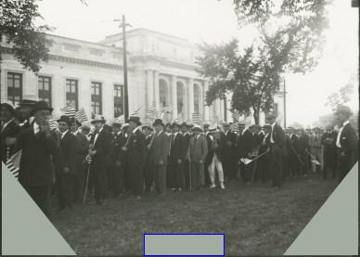

Third

Thursday

Photos

Page 21

In this Issue

June Third

Thursday

Page 22

 |  | At Risk - The Federal Investment in Libraries, |  |  |  |  |  |  |  |  |  |  |  |  |  |  |  |  |  |  |  |  |  |  |  |  |  | The Futures Conference
 |  |  |  |  |  |  | Archives, and Museums |  |  |  |  |  |  |  |  |  |  |  |  | 2-3 |  |  |  |  |  |  |  |  |  |  |  |  |  |  |  |  |  |  |  |  |  | 11
 |  |  |  |  |  |  |  |  |  |  |  |  |  |  |  |  |  |  |  |  |  | by Library Development Director Dawn La Valle
 |  |  |  |  |  | by State Librarian Kendall F. Wiggin
 |  |  |  |  |  | Bring History Alive for Kids! |  |  |  |  |  |  |  |  |  |  |  |  |  | 3 |  |  |  |  |  |  |  |  | New MLSC Hours-Pilot |  |  |  |  |  |  |  |  |  |  |  |  | 12
 |  |  |  |  |  |  |  | by IT Analyst Jackie Bagwell |  |  |  |  |  |  |  |  |  |  |  |  |  | by requestIT CT Coordinator Stephen Cauffman
 |  |  |  |  | Voices of WWI-CRIS Radio Project- |  |  |  |  |  |  |  |  |  |  |  |  |  |  |  |  | Restoration of the 1908 Model of the C S L
 |  |  |  |  |  |  |  |  |  |  |  |  |  |  |  |  |  |  |  | 4-5 |  |  |  |  |  | and Supreme Court Building |  |  |  |  |  |  |  |  |  |  |  |  |  |  |  | 13
 |  |  |  |  |  |  | by State Archivist Lizette Pelletier
 |  |  |  |  |  |  |  |  |  |  |  |  |  |  |  |  |  |  |  |  |  |  |  |  | by Museum Curator David J. Corrigan
 | For the Benefit of Our Children and Their Children: |  |  |  |  |  |  |  |  |  |  |  |  |  |  |  |  |  |  |  |  |  | Digitization of Factory View Post Cards
 |  |  |  |  |  |  | Documenting World War I |  |  |  |  |  |  |  |  |  |  |  |  | 6 |  |  |  |  | in the Museum of Connecticut History |  |  |  |  |  |  |  |  |  |  |  |  |  |  |  |  | 14
 |  |  |  |  |  | by State Librarian Kendall F. Wiggin |  |  |  |  |  |  |  |  |  |  |  |  |  |  |  |  |  |  | by Museum Curator David J. Corrigan
 |  |  | April 6, 2017 CT State Library WWI Centennial |  |  |  |  |  |  |  |  |  |  |  |  |  |  |  |  |  |  |  |  | The Strange Case of Jesse Montgomery
 |  |  |  |  |  |  |  |  |  |  |  |  |  |  |  |  |  |  |  | 7 |  |  |  |  |  |  | Seaver, Rogue Genealogist |  |  |  |  |  |  |  |  |  |  |  |  |  |  | 15-18
 |  |  |  |  | Commemoration by Editor Ursula Hunt
 |  |  |  |  |  |  |  |  |  |  |  |  |  |  |  |  |  |  |  |  |  |  |  |  | by Library Technician Glenn Sherman
 |  |  |  | Remarks from the World War I Centennial |  |  |  |  |  |  |  |  |  |  |  |  |  |  |  | 8 |  |  |  |  |  |  | Additions to the Collection |  |  |  |  |  |  |  |  |  |  |  |  |  |  | 19-20
 |  |  |  |  |  | by State Historian Walter Woodward |  |  |  |  |  |  |  |  |  |  |  |  |  |  |  |  |  |  |  |  |  |  |  | contributed by Staff
 |  |  |  |  |  |  | “The Great War” in 8 Weeks |  |  |  |  |  |  |  |  |  |  |  |  | 9 |  |  |  |  |  |  | State Library Board Update |  |  |  |  |  |  |  |  |  |  |  |  |  |  | 23
 | by Curator Patrick Smith-Museum of Connecticut History |  |  |  |  |  |  |  |  |  |  |  |  |  |  |  |  |  |  |  |  |  |  |  | by State Librarian Kendall F. Wiggin
 |  |  |  |  |  |  |  |  | WWI Twitter Project |  |  |  |  |  |  |  |  |  |  | 10 |  |  |  |  |  |  |  |  |  |  | In Memoriam |  |  |  |  |  |  |  |  |  |  | 24
 | submitted by WWI Project Coordinator Christine Pittsley
 | The CONNector |  |  |  |  |  |  |  |  |  | www.ctstatelibrary.org |  |  |  |  |  |  |  |  |  |  |  |  |  |  |  |  |  |  |  | May 2017

By State Librarian
Kendall F. Wiggin

At Risk - The Federal Investment in Libraries, Archives, and Museums

May 2017
Volume 19, No. 2
The CONNector Page 2

On March 16, 2017, President Donald Trump proposed a budget (America First - A Budget Blueprint to Make America Great Again) for discretionary spending in federal Fiscal Year 2018. It detailed proposed spending by department, amounting to an overall 10% increase in defense spending and a 10% decrease in non-defense outlays. Of great concern to libraries, archives,

museums and other memory institutions is the proposal to eliminate the National Endowment for the Arts (NEA), the National Endowment for the Humanities (NEH), and the Institute of Museum and Library Services (IMLS). Over the years these programs have funded a variety of important projects in libraries, museums, and archives across Connecticut. The State Library receives annual funding from IMLS under the Grants to States program as part of the Library Services and Technology Act (LSTA) and has been the direct beneficiary of several NEH and IMLS grants. For Federal Fiscal Year (FFY) 2016, the State Library received $2,022,715.00 in LSTA funds. Over the past several years the State Library has received NEH grants totaling $524,034 under the National Digital Newspaper Program. That funding is being used to digitize historically significant Connecticut newspapers for inclusion in the Library of Congress’ Chronicling America project.

As a rule, presidential budgets are pretty much dead on arrival. But we are in a political climate where some of the old rules don't apply. With Republican control of the Presidency and Congress, there is some reason to be concerned about the future of NEA, NEH, and IMLS . In 2015 the U.S. House Republicans issued "The Path to Prosperity: Fiscal Year 2015 Budget Resolution" which called for eliminating, you guessed it, the NEA, NEH, and IMLS. In reference to the IMLS, the plan said "[t]his function can be funded at the state and local level and augmented significantly by charitable contributions from the private sector." I think we all know the state and local funding situation. The LSTA funds have a maintenance of effort requirement which has been important in maintaining state funding for libraries.

The federal government has provided aid for public libraries since 1956. On June 19 of that year, President Eisenhower signed the Library Services Act (LSA) into law. Although the federal role in support of libraries has been questioned over the years, one constant has been the need to serve the underserved and the disadvantaged. There has been debate over the years as to whether the program should foster innovation through grants for demonstration projects or fund ongoing services.

A theme throughout the history of this program is the important role libraries play in providing the citizenry with access to learning opportunities and information in a variety of formats in a rapidly changing economy, and the need to support libraries in these efforts.

Throughout its history, the program has been state based. With overall goals established by Congress, the states have administered their grants to best meet the needs of their libraries and the citizens they serve.

Congress debated the Library Services and Construction Act in 1963 as the successor to LSA. In the debates,

Thomas McIntyre (D-NH) stated that:

We are living in a complex and rapidly changing age. It is an age built upon the creation, the collection, and the rapid dissemination of accurate information. At the very heart of this communications chain stands the American free public library which collects and makes available books and other materials to all who have need of them.

The CONNector www.ctstatelibrary.org May 2017

May 2017

Volume 19, No. 2

continued from previous page

The CONNector Page 3
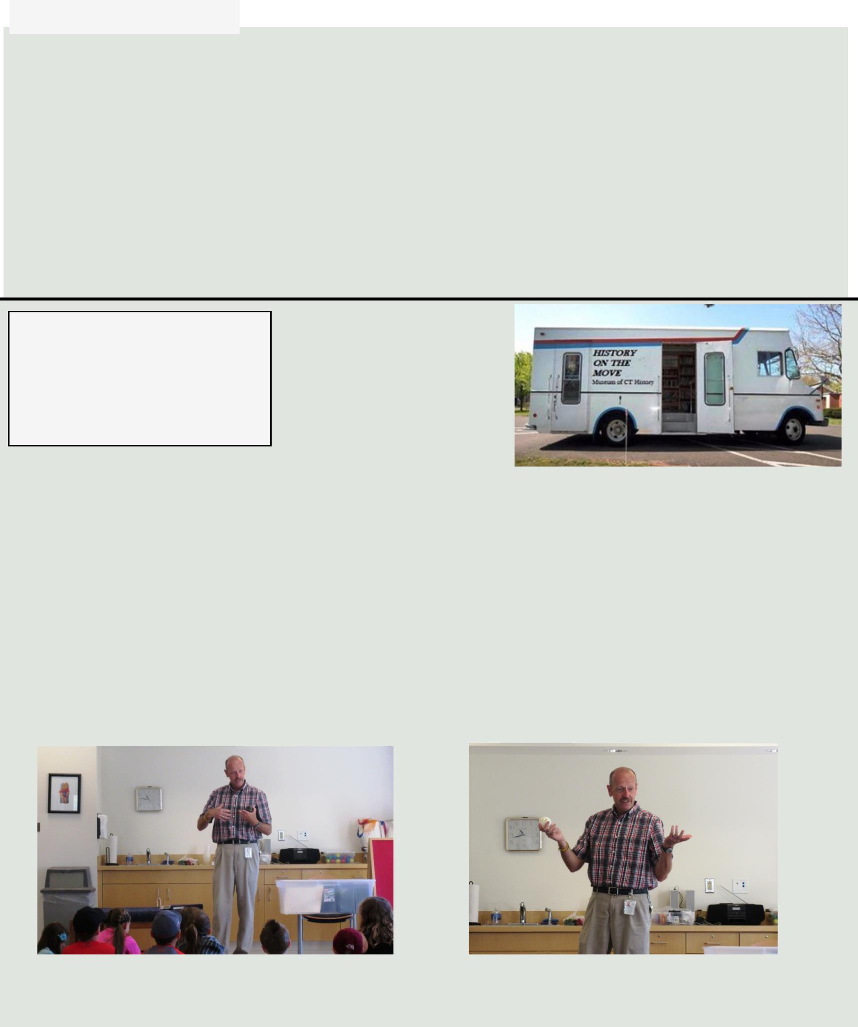

Those words could not be more true today. Funding for public libraries in Connecticut derives mainly from local tax dollars and private support. State funding supports the sharing of resources across all libraries, lessening the burden on any one library while providing the citizens of the state with the information they need. Federal funds are matched by state funds to support library services to the blind, those with print disabilities and those with physical disabilities; resource sharing; and innovation in libraries through small grants. Libraries are a national resource that deserve support from government at all levels. Now is not the time to cut the modest, but effective, federal investment in libraries. In fact, let's think big - how about a federal investment of $1.00 per capita.

Federal funds are matched by state funds to support library services to the blind, those with print disabilities and those with physical disabilities; resource sharing; and innovation in libraries through small grants.

Bring History Alive for Kids

By IT Analyst Jacqueline Bagwell

The Museum of Connecticut History has great stuff but not every school can get their students to Hartford to see many of these treasures first hand. So our Museum

Curator Patrick Smith goes out to many schools every year to

connect students with Connecticut history. To make history vibrant and engaging in schools the Museum of Connecticut History wants to do more and bring the historical treasures to the schools.

History on the Move project intends to use a refurbished bookmobile, for our Museum Curator to load up with fascinating artifacts for display and present wonderful programs to schools around the state

Would you like to help our Museum Curator Patrick Smith bring items from the Museum of CT History to school children across the state? Our goal is to retrofit the bookmobile, pictured here, to accommodate books and historical items from the Museum of Connecticut History.

This would enable Patrick to carry educational items to schools throughout the state. If you are interested in helping support this fine project read more on our website or go straight to the Go Fund Me page!

Museum Curator Patrick Smith speaking with an attentive group of children at the Somers Public Library during a “Connecticut Invents” program. To the right is Patrick with the Connecticut made wiffle ball.

The CONNector www.ctstatelibrary.org May 2017

May 2017

Volume 19, No. 2

Voices of WWI-CRIS Radio Project-Kick Off

By State Archivist Lizette Pelletier

The CONNector Page 4

Project Launch-March 6 2016 in the Museum of CT History-From left to right, Secretary of the State Denise Merrill, Director of Education and Rehabilitation Brian Sigman, CRIS Radio Executive Diane Weaver Dunne, CRIS Radio Chairman Paul A. Young, U.S. World War One Centennial Commissioner John Monahan, Education Consultant Steve Armstrong, and State Librarian Kendall Wiggin.

Picture Credit: CRIS Radio

On March 20, 2017, state officials, historians, archivists, educators, and CRIS Radio (Connecticut Radio Information System) board, staff and volunteers gathered in Memorial Hall of the Museum of Connecticut History to launch a collaborative pilot project called “Voices of World War I.” CRIS Radio, the Connecticut State Library, and IDEAL Group have worked together over the past two years to develop a first-of-its kind service to provide access to historic records and documents through human-narrated recordings for individuals who are blind or unable to read due to other print disabilities. The goal of this project is to demonstrate that archives and libraries can provide these individuals with access to the same historic documents that other students, researchers, and citizens have enjoyed. Financial support for this project is provided in part by the National Historic Publication & Records Commission [NHPRC], which is the funding arm of the National Archives and Records Administration [NARA] in Washington DC.

Because the project coincided with the centenary commemoration of WWI, State Archives staff along with the project's advisory committee selected more than 100 historic WWI era documents from the State Library's extensive archival and government documents collection, including servicemen’s diaries and letters to home, government-pamphlets such as “Cutting Your Meat Bills with Milk,” and selections of articles published in Connecticut newspapers from the era. The staff also selected a number of the military service questionnaires that State Librarian George S. Godard developed and collected during 1920-1930 from veterans and family members of those who died in combat that captured their memories and feeling about their service. Staff from the State Library's Connecticut in WW1 project scanned the documents. Other staff and volunteers provided transcripts of handwritten materials. CRIS radio volunteers then recorded each item as the person writing would have read it aloud. Careful attention was paid to pronunciation. The audio files are available on the CRIS website http://crisradio.org/.

As part of the launch celebration, State Archives staff put a selection of the documents recorded in two display cases in Memorial Hall. CRIS staff provided for each of the documents QR codes developed for its CRISACCESSTM museum service. Visitors are able to use their smart phones to listen to the human narrated

The CONNector www.ctstatelibrary.org May 2017

May 2017

Volume 19, No. 2

The CONNector Page 5
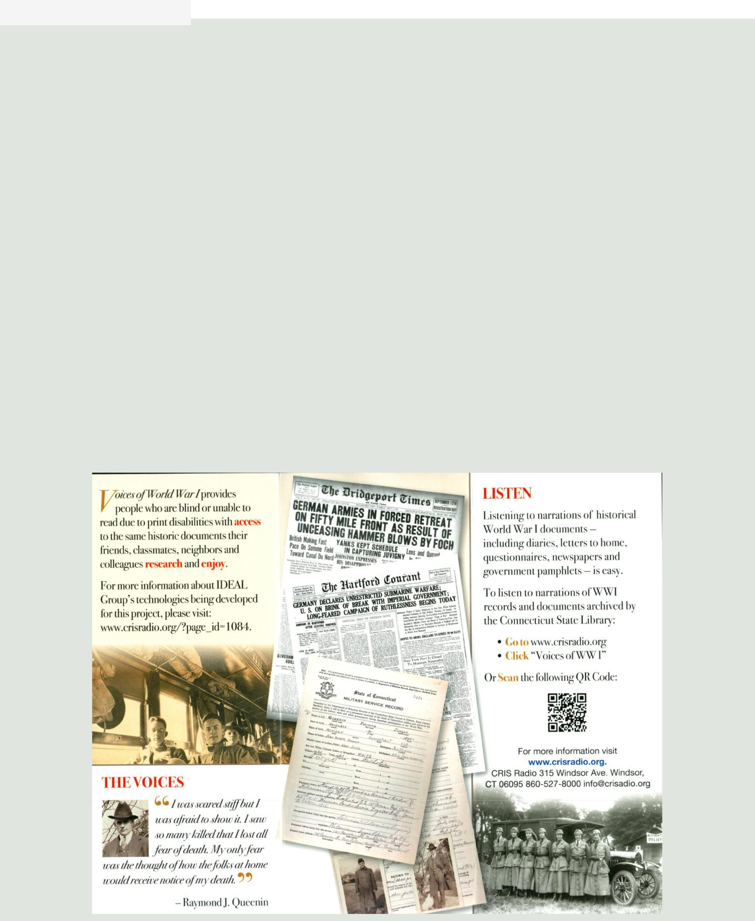

continued from previous page

recording for each document while they are viewing it in the case.

The project also included the development of new technologies to help teachers, librarians, and archivists render hard-copy historical documents into accessible formats for individuals with print disabilities as well as make them searchable. The new technology tools were developed by IDEAL Group, an Ohio-based company that makes accessible mobile applications for people with disabilities. Following the launch celebration, Ideal Group President Steve Jacobs and CRIS Radio Executive Director Diane Weaver Dunne demonstrated the new technology to members of the Connecticut State Historical Records Advisory Board and interested State Library staff members at the State Library's 75 Van Block Avenue facility. At the end of the grant, the tools will be made available free of charge to archives, libraries, and other institutions to allow them to expand accessibility of their collections.

As the project progressed, educators on the project advisory committee realized that the recordings will also benefit classroom teachers by bringing history alive for their students. Rather than just reading about an event or viewing static images, students will be able to hear a letter, diary or other contemporary account read aloud.

To listen to recordings go to www.crisradio.org and click on “Voices of WWI”. For more on the State Library’s WWI collections and events, visit the Connecticut in the Great War website at http://ctinworldwar1.org or the State Library's website at www.ctstatelibrary.org. For more information about IDEAL Group see: http:// ideal-group.org, http://inftyreader.org, http://apps4android.org, and http://kds.global.

The CONNector www.ctstatelibrary.org May 2017

May 2017

Volume 19, No. 2

For the Benefit of Our Children and Their Children: Documenting World War I

By State Librarian

Kendall F. Wiggin

The CONNector Page 6

(This article first appeared in Connecticut Explored Vol.15, No 2, Spring 2017.)

In Connecticut, we are very fortunate to have incredible primary and secondary resource materials in unique collections around the state. The fact that some of the most significant records are held in the Connecticut State Archives is largely attributable to the vision and drive of one man, State Librarian George Godard (1900-1936).

In 1917 the General Assembly passed legislation that provided for the depositing in the State Library all of the files and other official papers relating to the State Council of Defense, the Connecticut State Military Census, and other similar organizations in connection with the World War. At that time the State Council of Defense established the Department of Historical Records within the State Library under the direction of Godard.

On November 2, 1918 the Committee on Historical Records, which advised the Department of Historical Records and was chaired by Godard, met and decided that is was of great importance to secure from the several committees and departments that had been created by the Connecticut State Council of Defense a "full statement covering the work accomplished or in progress . . . ." Godard was instructed to request these reports and on November 14, 1918, just three days after the armistice was signed, Godard wrote to the chairman of the Town War Bureaus across Connecticut saying that their reports "will be essential to an adequate understanding" of the services their committee provided. He went on to say that the committee was "interested in having available when needed the material necessary to formulate a true and adequate narrative of the part it has been Connecticut's duty and privilege to take. It is the duty of the Department of Historical Records to see that such official and reliable data is secured and made available here in our State Library."

In 1919 the Department of Historical records became the Department of War Records by act of the General Assembly. The goal of the War Records Department was, according to Godard, “to collect, classify, index and install all available material relating to Connecticut’s participation, public or private, in the World War . . . or the benefit of our children and their children.” So eager was Godard to show off the work of the Department of War Records, that he invited a reporter from the Hartford Courant for a tour. The story appeared in the Harford Courant on July 27, 1919 under the headline "Preserving the Records of Connecticut's Soldiers" with the sub heading "Our state leads all others in the way it is tabulating the information concerning the sons who went forth to do their part in making the world safe for democracy." The reporter noted that Godard was "intensely interested in this work" and "convinced of the great value" of the records the Library had acquired and continued to acquire. While many state's had found the task of indexing and classifying their war related records daunting, Connecticut was "sailing along serenely under the leadership of the state librarian, with a system that is simplicity itself."

In 1975 the General Assembly repealed the language establishing the Department of War Records and instead substituted language calling for the State Library to maintain a collection of war records which it continues to do to this day.

Few states have the breadth and depth of documentation of the state role in the buildup to the United States entry into the war and participation in the war as does Connecticut. Because of Godard's leadership and his innate sense of the importance of documenting history and the diligent work of the women and men in the State Library's Department of War Records, today we are able to tell the story of Connecticut’s Role in the Great War.

The CONNector www.ctstatelibrary.org May 2017

May 2017

Volume 19, No. 2

The CONNector Page 7
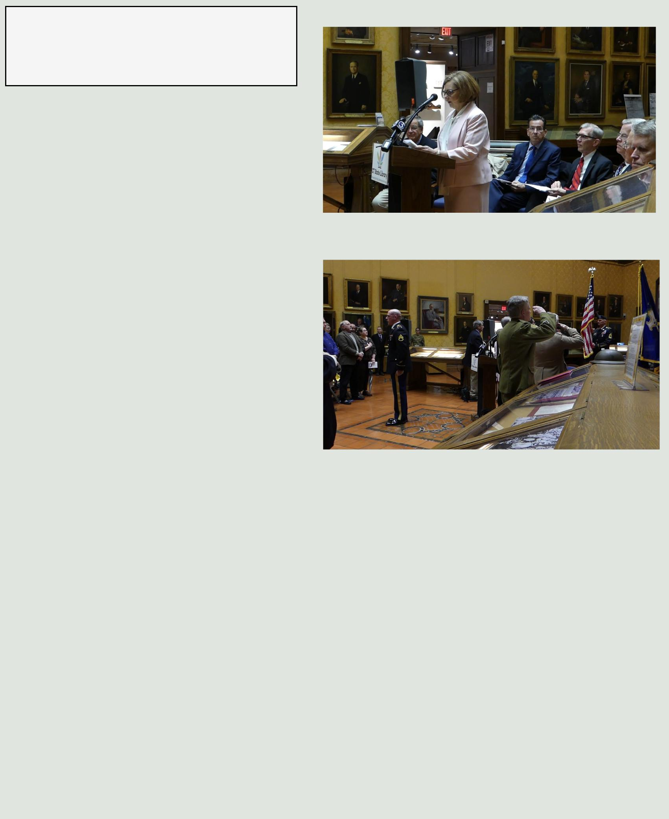

April 6, 2017 CT State Library WWI Centennial Commemoration

By the Editor, Ursula Hunt

The Connecticut State Library commemorated the 100th anniversary of the United States' entry into World War I with an event in Memorial Hall that included the Posting and Retiring of the Colors by the Connecticut National Guard, remarks from Governor Dannel Malloy, State Librarian Kendall Wiggin, Commissioner Dianna Wentzell, State Historian Walter Woodward, Commissioner of Veterans Affairs Sean Connolly, Lieutenant Colonel Timothy Tomcho, George King III and Dr. Jeffrey Klinger from the Ambulance 255 Project. The event began with a beautiful rendition of the National Anthem sung by Sgt. Joseph Colavito, 102nd Army Band. Kendall Wiggin began the presentations by thanking the former State Librarian George Seymour Godard for recognizing the value of collecting the ‘treasure trove” of records from Connecticut World War I Veterans. He commended Christine Pittsley for her efforts in organizing Connecticut’s Remembering World War One: Sharing History/Preserving Memory project, which has evolved over the past year. Please visit

Education Commisioner Dianna R. Wentzell

with other distinguished guests.

Sgt. Joseph Colavito, 102nd Army Band,

singing the National Anthem

the website at http://ctinworldwar1.org/ to see images collected from over 100 descendents of the war and news about digitization and other events taking place throughout the state . Governor Malloy recognized the State of Connecticut for its many contributions to the war. State Historian Walter Woodward spoke about Connecticut’s massive role in manufacturing efforts and the impact on Connecticut’s workforce (see his remarks on the next page). He also spoke of Governor Holcomb’s involvement and the great patriotism shown by Connecticut residents. Education Commissioner and State Library Board Member Dianna Wentzell spoke about the importance of bringing the history of WWI into the classroom and she thanked the organizations that have helped provide the necessary material for history and social study teachers in the state. Military Department Lieutenant Colonel Timothy Tomcho spoke about the Connecticut National Guard’s contributions and Connecticut Legislation passed during the war period that was instrumental to our success. Commissioner of Veterans Affairs Sean Connolly welcomed and recognized veterans from all wars and the importance of organizations that work together to preserve their legacy. George King III from the Ambulance 255 Project and his colleague Dr. Jeffrey Klinger were not able to bring a 1914 model ambulance, which they restored, due to rain, buy they did bring photographs and a video. The ambulance was used to evacuate soldiers during the war. Dr. Klinger spoke about the challenges and tragedies faced by both drivers and soldiers. He also mentioned the value of being able to share these stories with others, however difficult that may be. Watch the CTN Video of the Event on the CTN Website or watch the video from the CSL Website.

The CONNector www.ctstatelibrary.org May 2017

May 2017

Volume 19, No. 2

The CONNector Page 8

Remarks from the World War I | (These remarks were presented at The Yanks Are Coming:
Centennial Commemoration | Connecticut’s Centennial Commemoration of the U.S. Entry
 | into World War I on April 6, 2017 in the Museum of CT
By State Historian Walter Woodward | History)

When World War I began in July, 1914, most Connecticans viewed it as

a spectator event – someone else’s fight, in a place far away. In his 1915 state of the state speech to the General Assembly, Governor Marcus Holcombe failed to mention the war as something that would affect Connecticut.

But affect that state it did – profoundly and almost immediately.

From the beginning, the warring European powers flooded Connecticut’s arms makers with huge orders. Connecticut became England and France’s armory years before it became its ally.

In Bridgeport, New Haven, Hartford and the Brass Valley, munitions factories ramped up production on a massive scale, hiring thousands of new workers – never enough - and pushing them to provide maximum output. The pressure to produce led to labor strife– the 422 strikes affecting 68,000 workers in 1915 and 16 were the most in the state’s history, though the arc of increased production was unwavering.

Holcombe was quick to conclude that American involvement in a war of this scale was a question of when not if and even as the nation prepared to reelect Woodrow Wilson on a campaign slogan that said “He Kept Us Out of the War”. Holcombe bent his efforts to preparing Connecticut and Connecticans for the battles to come.

The sinking of the passenger liners Lusitania in May 1915, and the Sussex in 1916, fed Connectican’s anti-German hostility, as did rumors – related to the state’s massive defense production – that Germany secretly planned to use the state as a base for fifth-column saboteurs. Warned by a Holcombe official that “the penalty for failure to prepare is national death,” Connecticut mobilized well in advance of American entry into the war. In 1915 and 1916, encouraged by state officials, business men paid their own expenses to receive military training at a camp in Plattsburgh New York. Yale alumni funded construction of an on campus armory. 100,000 spectators lined Hartford streets to watch 17,000 marchers stage a patriotic preparedness parade in June of 1916. Similar marches were held in cities and towns around the state. That same summer, the Connecticut State Guard was the first to answer Woodrow Wilson’s call to mobilize troops to stop the cross border incursion of the Mexican guerilla Pancho Villa into Arizona.

Other states may have voted for isolationism, but Holcombe, without making a single campaign speech, was reelected in the fall of 1916 on a platform of preparedness.

When Germany, in January of 1917, declared their intention to sink all North Atlantic shipping, Holcombe recognized war was imminent, and called on Connecticans to set aside any and all differences and “meet on the common plane of patriotism”.

Within two months, a volunteer group of over 10,000 citizens conducted and completed a statewide census of every Connecticut male over 16 years to determine their capacities and ability to serve in the military in case of a draft. A home guard was created to protect the state’s factories and infrastructure from sabotage, and in three months 10,000 men ranging from Civil War veterans to high school students, were organized, uniformed and armed. So by the time this day came, 100 years ago today, Connecticut and its people were ready for war. Connecticut troops would be among the first to see action in France, and earn fame, honor, and respect for their battlefield bravery and courage under fire. And they would be supported back home by a populace of men women and children committed to sacrifice and service on the home front, in the cause of peace. And sacrifice they did, but that’s another story, for another time.

As Governor Holcombe would say. “The war aroused us from our lethargy and for eighteen months we thought seriously, and acted patriotically, and unitedly.” It is that seriousness, and patriotism, that readiness to pay the price of freedom, that we remember, and give thanks for today.

The CONNector www.ctstatelibrary.org May 2017

Stubby with his
owner/best friend PVT.
James Robert
Conroy

By Curator Patrick Smith-Museum of Connecticut History

“The Great War” in 8 Weeks

May 2017
Volume 19, No. 2
The CONNector Page 9
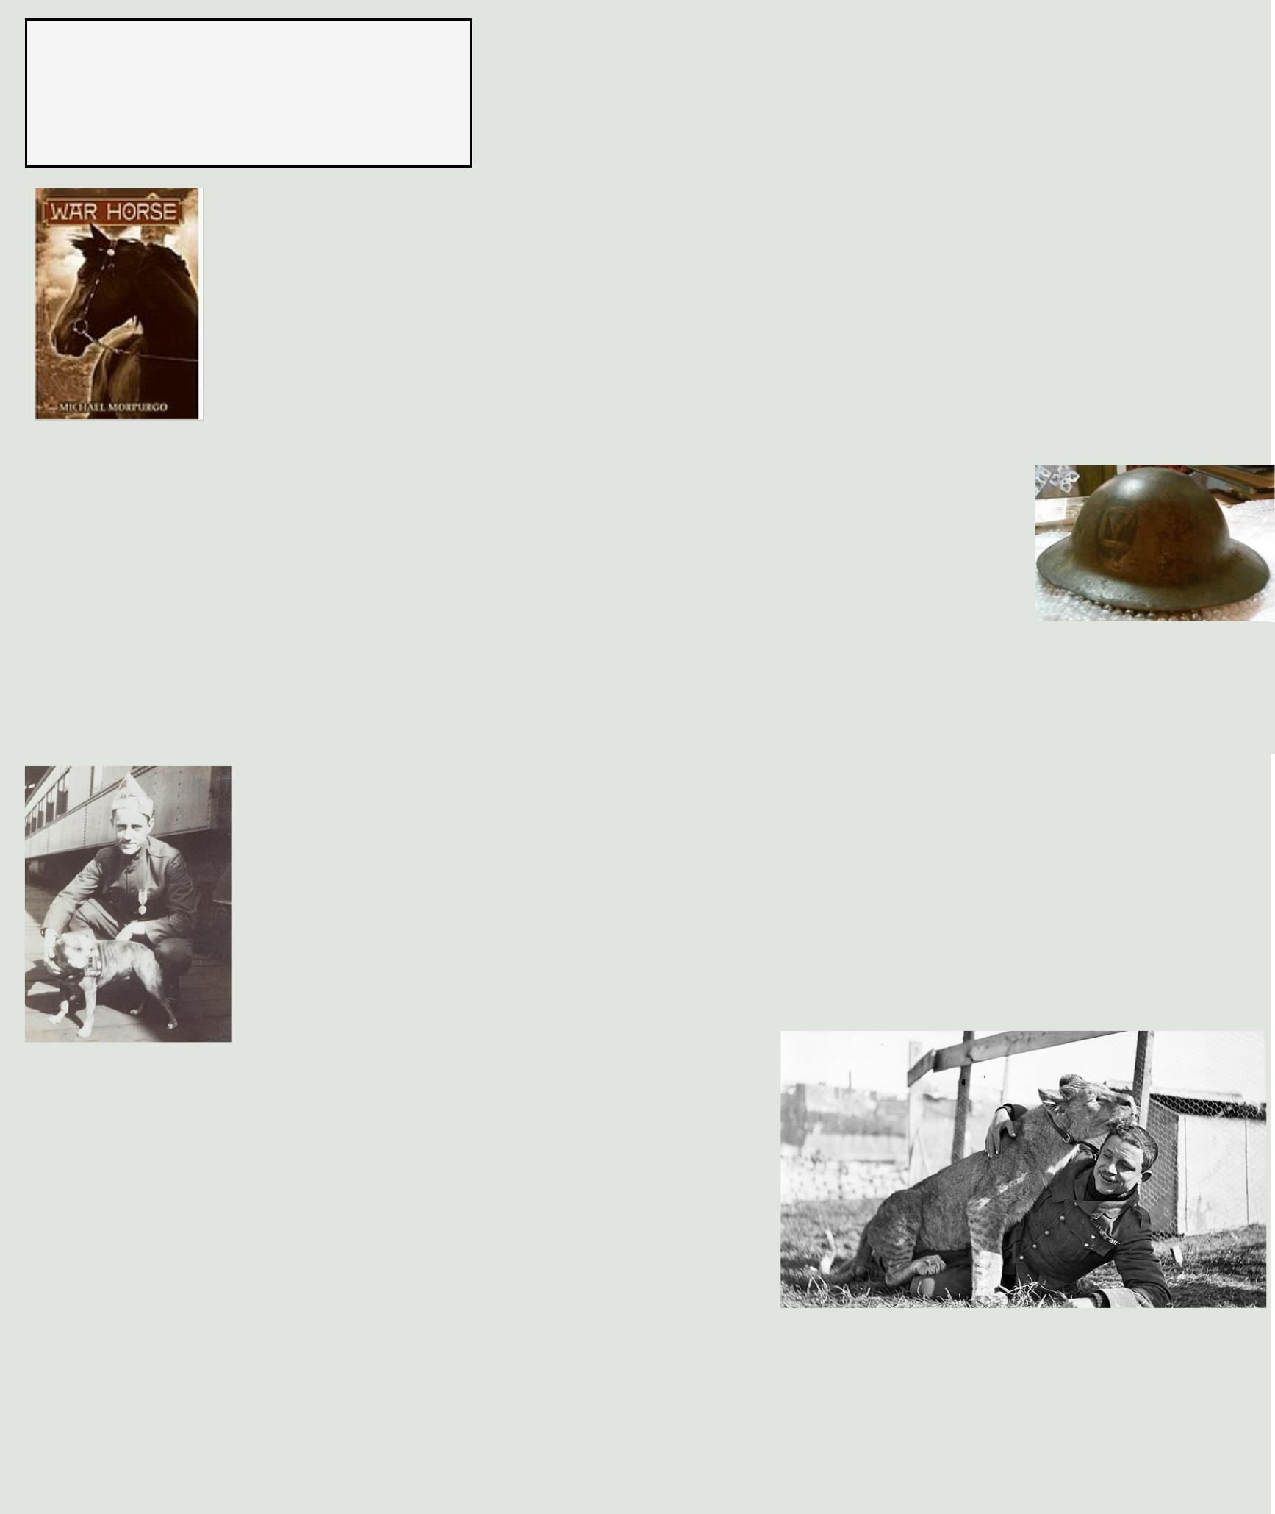

Connecticut’s role in World War I was featured as part of a class “Send the Word....The Yanks are Coming” presented to a group of 4th-6th

grade home schooled students. I recently finished teaching this eight-week class, which I created, to seventeen students as part of the Monday Home School classes hosted by the Lutz Museum in

Manchester. Each week the kids and I delved into a new topic related to the Great War and Connecticut’s role in it. Objects, documents, and images from the Museum and Library made the topic come alive for the kids who were thrilled to see what new treasures I brought in each week. The students who signed up for the class were also provided with the book War Horse by Michael Morpurgo, and as a group we read the book and explored topics in it each week. We covered a lot of history in eight weeks!

The class began with a look at the pre-war political situation in the world and several events that acted as a trigger for the war. We of course looked at famous battles and soldiers' stories from the many nations that took part. Letters, descriptions, and documents from Connecticut soldiers brought the war closer to home for those in the class. One of my favorite classes was one where we looked at trench fighting during the war. I set up the classroom as a “trench” using desks and tables for the trenches and overturned chairs as barbed wire in “no man’s land." I had the kids tucked down low as I read descriptions of the miserable conditions in the trenches and showed them pictures from several fronts of the war. Periodically I lobbed paper “mortars” to keep them on their toes.

WWI “Brodie” helmet from the Museum’s collection

The technology of war really changed during WWI. We examined the

role of airplanes, submarines, and tanks. Connecticut aviators were highlighted and our industrial output, including tanks, other weapons, and military supplies made in the Nutmeg State were featured. The effort on the home front back here in Connecticut included learning about war bond drives, Red Cross efforts, and food conservation. A different perspective on the war was shown by using art, music, and poetry of the period. We all went “Over There” for a time.

The book War Horse allowed us a chance to look at many different wartime experiences. Animals played a big part in the war, and we learned about the use and care of horses, pigeons, and of course dogs, including Connecticut’s own Sergeant Stubby. The book

also gave us a glimpse into the disastrous effect the war had on civilians throughout Europe and beyond, including children and young adults who fought in many battles or suffered its consequences. As we finished the book and the semester, the kids and I discussed the outcome of the war and what came after the “War to End All Wars" -- it was of course World War II. A few of the kids and parents asked if I was teaching about that next -- I think I’ll need more than eight weeks!

Major Gervais Raoul Lufberry (and a unit

mascot!) who lived for a short time in Connecticut and flew for the Lafayette Escadrille during the war.

The CONNector www.ctstatelibrary.org May 2017

May 2017

Volume 19, No. 2

The CONNector Page 10

World War I Twitter Project | State Library Launching WWI Twitter Campaign
Submitted by WWI Project | Featuring Hartford Courant's Original Coverage
Coordinator Christine Pittsley
 | Article written by Staff Writer Gregory Hladky, Copyright ©

1764-2017. Hartford Courant. Used with Permission.

A century after the U.S. joined "the war to end all wars," the Connecticut State Library is launching a project to use Twitter as a vehicle for historical posts featuring the daily coverage of World War I from the Hartford Courant.

The "Over the Top: Hartford Courant Reports the Great War" social media campaign is intended to give today's internet-oriented generation a sense of how the war was reported on a day-to-day basis when the U.S. entered the conflict. Each post will show the Courant's front page from that particular day during the war.

Library officials plan to follow each day's Hartford Courant posts with other tweets about other Connecticut stories relating to the war, both at the front in Europe and at home.

"We've been thinking about this for a while," said Christine Pittsley, project manager for the library's new Twitter campaign. About a month ago, officials decided to go ahead with the social media effort.

"This is a way to get this information out there," Pittsley said, and to give 21st Century people a feeling for how newspapers covered major events 100 years ago. "Most people on social media probably don't read newspapers anymore," she said.

Additional, more in-depth stories on topics including manufacturing of gas masks to whether public schools should be required to provide military training will also be posted on the Library's Facebook page. Pittsley said

Library officials will be working on those in-depth articles with Connecticut History.org, an arm of the non-profit group, Connecticut Humanities.

There will also be images from the Hartford Courant added to Instagram. Those images will come from ProQuest, which has put together a digital database of the Hartford Courant's archives to make it available to libraries and researchers.

Anyone interested in the World War I Twitter campaign can follow it via @CtinWW1, or #OTTHC. The in-depth content on Facebook can be accessed by going to @Ctin WorldWar1 or on Instagram, @CtinWW1.

President Woodrow Wilson asked Congress on April 2, 1917 for a declaration of war against Imperial Germany. His request came more than two-and-a-half years after the start of WWI at a time when Germany and its opponents, Great Britain, France and Italy, were locked in a trench-war stalemate across Europe.

Wilson's decision came after a series of controversies, including the sinking of the British passenger ship the Lusitania in 1915 that resulted in the deaths of 128 Americans and disputes over Germany's unrestricted submarine warfare. In early 1917, Germany infuriated the U.S. by sending the famous "Zimmerman Telegram" to Mexico, urging that nation to go to war against the U.S. in the event American declared war on Germany.

The war ended on Nov. 11, 1918 with Germany's defeat.

The CONNector www.ctstatelibrary.org May 2017

